Flea Prepration Sheet
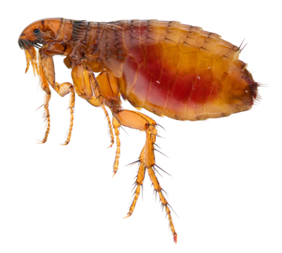
Preparing For Your Flea Treatment:
Proper preparation is key to getting rid of your Flea infestation. Empire Pest Control will provide you with a detailed check list on what to do to be prepared for your scheduled treatment. We cannot stress the importance that these items are taken care of to ensure the most effective results.
Please note: Empire Pest Control will not provide treatment to a property that has not meet the criteria of the checklist. All homes that have excess clutter will NOT be treated. A successful treatment cannot be achieved where there is excess clutter and untidiness.

Home Preparation:
Removal of fleas by vacuuming thoroughly is an important part of preparing for the treatment process. Use the crevice attachment to access furniture interiors, baseboards and any other place a fleas could be hiding.
- Pick up all items off ALL carpeted or cement floors everything except furniture. Place items on tables, shelves, linoleum floors or tiled floors.
- Vacuum floors, carpets and area rugs, under cushions of couch & chairs, under beds, in closets.
- Discard of vacuum bag in outside garbage, replace with new bag add moth balls & flea powder.
- Sweep & mop all cement, linoleum and tiled floors.

Laundering:
Everything that can be washed should, then place in clean/new plastic bags or plastic containers.
- Wash all linens, clothing, stuffed animals, drapes, bedding, bed skirts etc.
- Use the highest allowable heat seating for both the washer and dryer whenever possible.

Post Treatment:
Upon completed treatment we recommend staying out of the home for minimum of four hours. This allows an appropriate amount of time for the materials to dry. After the allotted time you, your children and pets may re-enter and resume normal household activities. However, to prevent repeating we recommend all pets must be professionally treated at the time of service and for minimum of two months after service.
Empire Pest Control
616-796-8900
11867 Greenway Drive Ste #30 – Holland MI 49424

